**Feasibility Analysis Document: Inline Editing in a Table**

**Introduction**: The purpose of this feasibility analysis document is to assess the technical feasibility of implementing an "Inline editing in a table" as a data widget which can be used in pages for data representation. The Editable Table widget aims to give user the option to edit the data without opening another page.

 **Background:**

The EditableTable widget will enhance user experience giving user the option to edit the data without opening another page. This action can be used in scenarios where an overview page is required in which you can represent data as well as manipulate it.

**Feasibility Analysis**:

**Expected End Result:**

**Mendix Marketplace and Forum analysis:**

Explored multiple things in mendix marketplace but didn’t found any widget which will fulfil this kind of requirement.

Although, there is a way to implement this using the current DataGrid 2.0 in mendix but we need to use visibility conditions to achieve it.

**How to implement Inline editing in DataGrid 2.0:**

**Step1:** Take a Boolean attribute in your entity naming “IsEditable” and keep the default value as false.

**Step2:** Use DataGrid 2.0 on your page and while configuring the columns use “Custom Content” option.

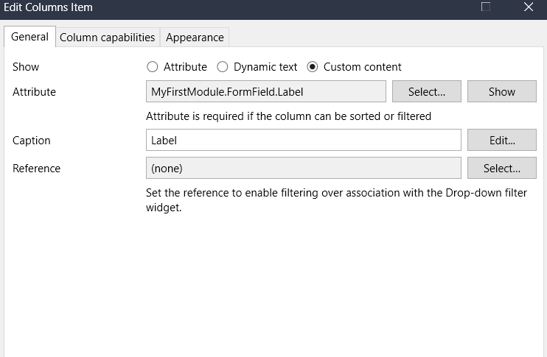

**Step3:** Now add input widget (as per your requirement or attribute’s nature) and also add static text widget.

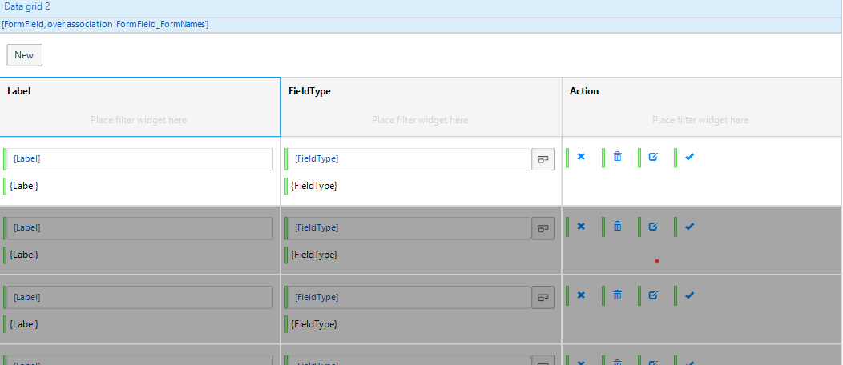

**Step4**: Add visibility condition to the input widget and static text.

Show Input widget when IsEditable = true

Show Static text when IsEditable = false

**Step5**: Add 4 action button to your last column and add visibility condition to them.

Save button when IsEditable = true

Cancel button when IsEditable = true (default cancel button or as per your requirement)

Delete button when IsEditable = false (default delete button or as per your requirement)

Edit button when IsEditable = false

**Step6**: Add microflow action to Edit and Save button.

Edit button: Change the IsEditable to true and use refresh in client option.

Save button: Change the IsEditable to false and commit the changes.

**UI Screenshots**:

